**NAME: Sharvayu Zade**

**PRN: 23070521135**

**SEM 4**

**Aim of Practical 5: Write and execute SQL queries subqueries, joins.**

**Practical 5 part 1**

**SQL Subqueries**

**What is a Subquery?**

A **subquery** is a query inside another query, used to retrieve intermediate results before executing the main query.

**Types of Subqueries:**

1. **Single-row subqueries** → Return a single value.

2. **Multi-row subqueries** → Return multiple values.

3. **Correlated subqueries** → Reference columns from the outer query. **Example Database: Supermarket**

Use a **SupermarketDB** with the following tables:

**Customer** (customer_id, name, email, phone, address)

**Product** (product_id, name, category, price, stock_quantity)

**Order_Details** (order_id, customer_id, order_date, total_amount)

**Order_Item** (order_id, product_id, quantity, subtotal)

**Employeee** (employee_id, name, role, salary, hire_date)

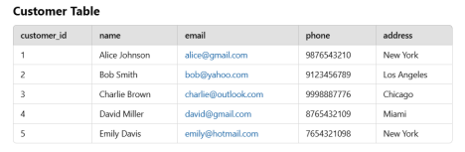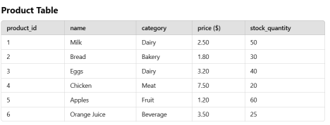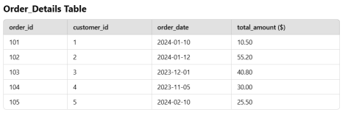

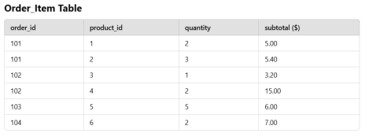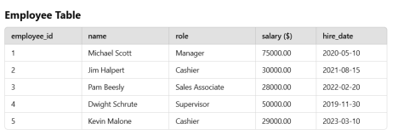

**Examples of Subqueries**

**Find customers who placed orders over $50.00**

SELECT * FROM Customer

WHERE customer_id IN (SELECT customer_id FROM Order_Details WHERE total_amount > 50);

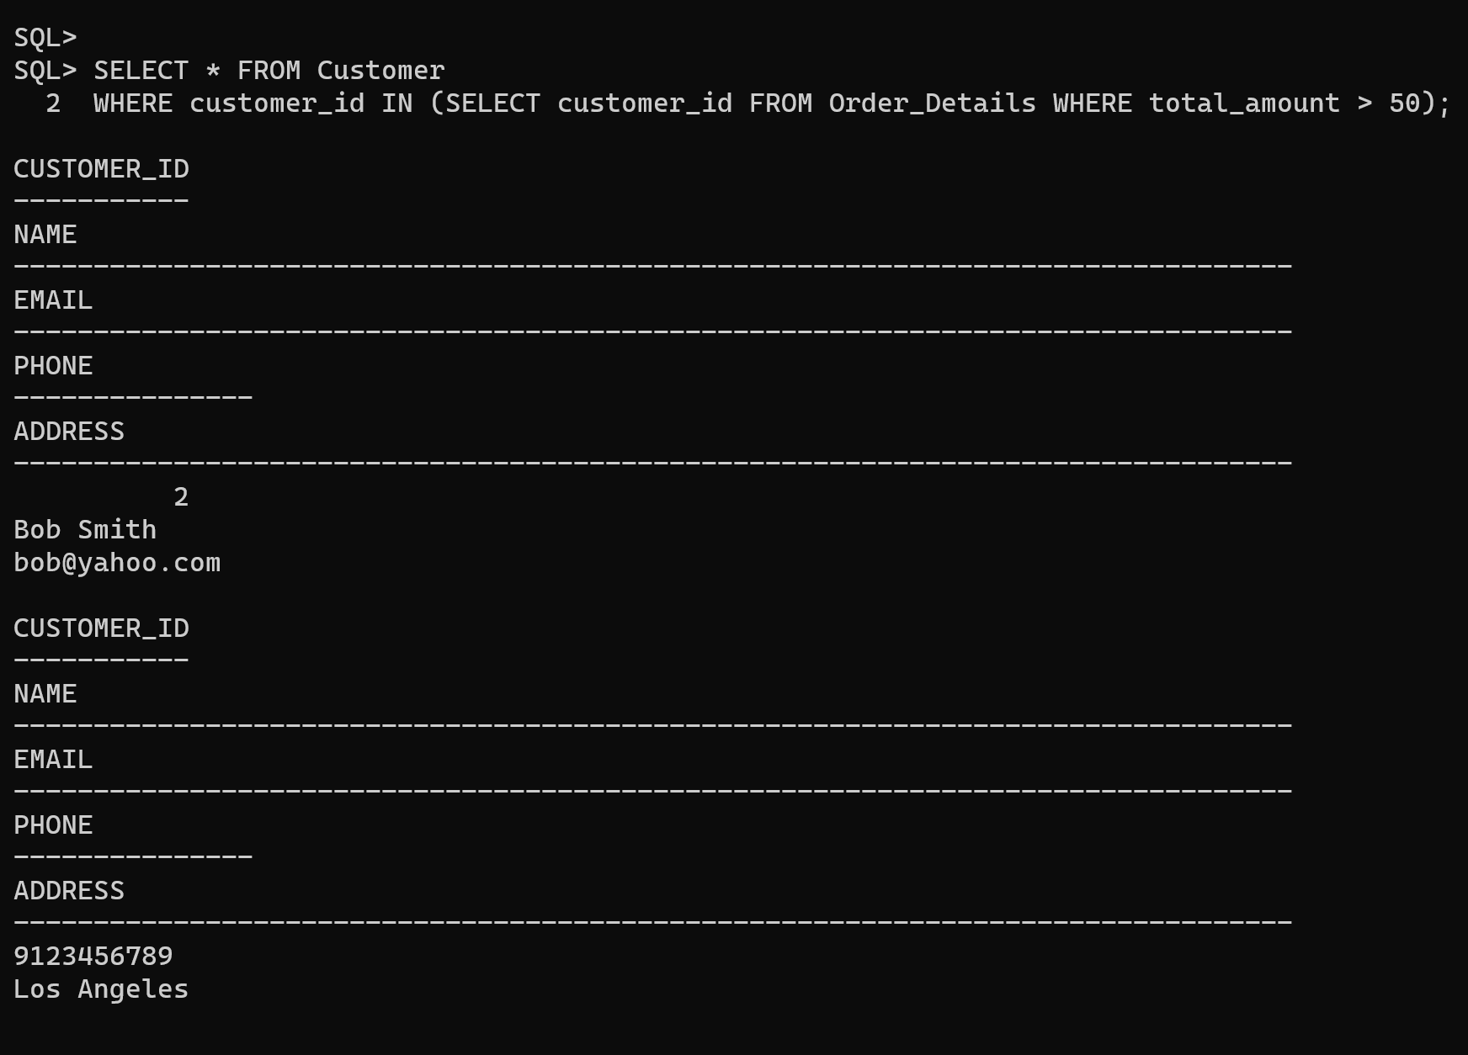

**Retrieve products that cost more than the average product price** SELECT * FROM Product

WHERE price > (SELECT AVG(price) FROM Product);

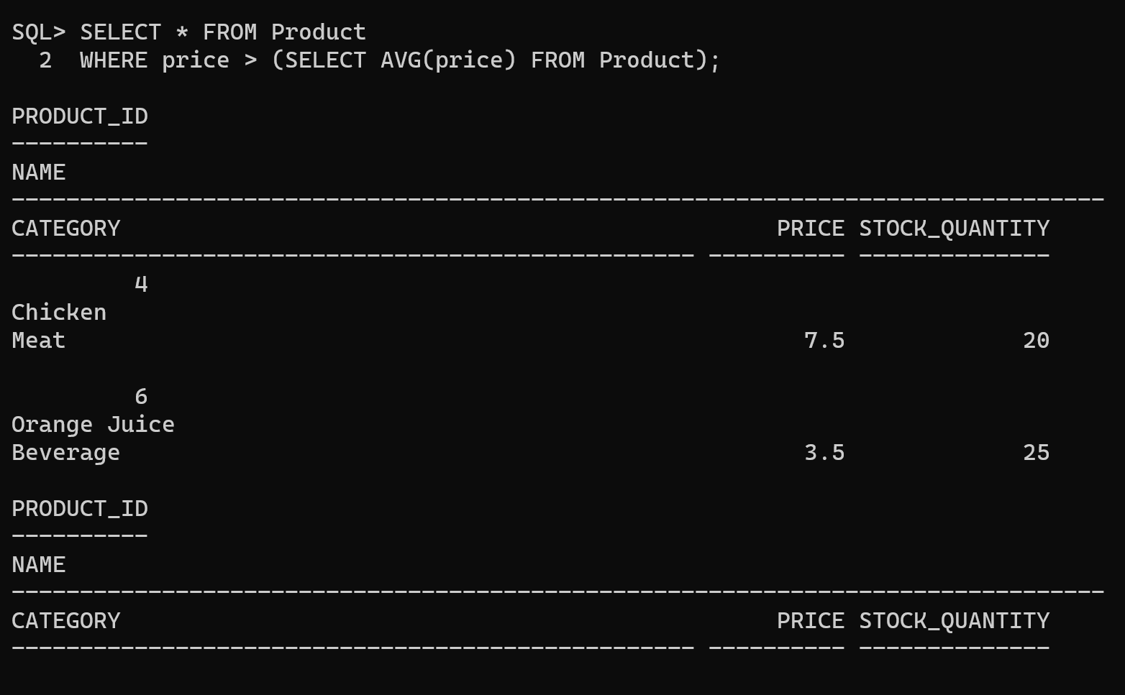

**Find employees earning more than the lowest manager’s salary** SELECT * FROM Employeee

WHERE salary > (SELECT MIN(salary) FROM Employeee WHERE role = 'Manager');

**Find employees hired after the most recent hire date of a cashier** SELECT * FROM Employeee

WHERE hire_date > (SELECT MAX(hire_date) FROM Employeee WHERE role = 'Cashier');

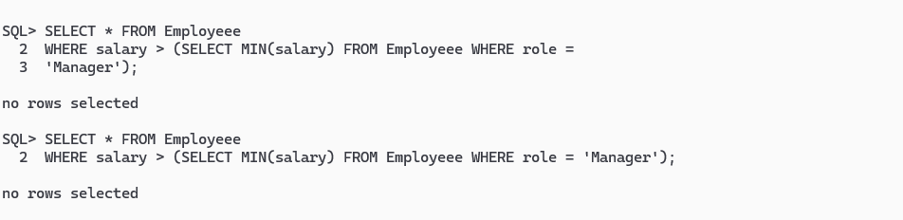

**Find customers who haven’t placed any orders**

SELECT * FROM Customer

WHERE customer_id NOT IN (SELECT customer_id FROM Order_Details);

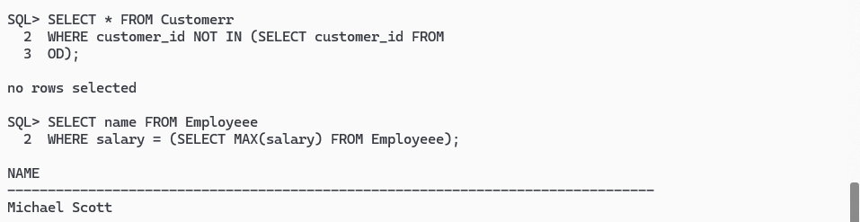

**Find the name of the highest-paid employee**

SELECT name FROM Employeee

WHERE salary = (SELECT MAX(salary) FROM Employeee);

**Retrieve the total revenue generated from orders placed in January 2024** SELECT SUM(total_amount)

FROM Order_Details

WHERE order_date BETWEEN TO_DATE('2024-01-01', 'YYYY-MM-DD') AND TO_DATE('2024-01-31', 'YYYY-MM-DD');

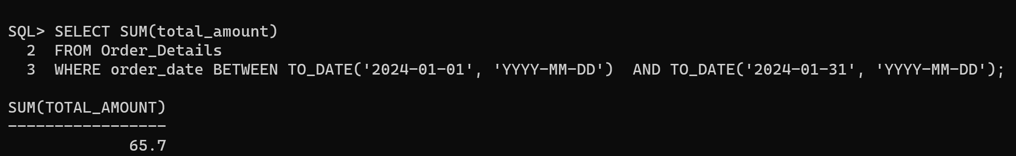

**Find the most ordered product**

SELECT name FROM Product

WHERE product_id = (SELECT product_id FROM (

SELECT product_id, SUM(quantity) AS total_sold FROM Order_Item

GROUP BY product_id

ORDER BY total_sold DESC

)

WHERE ROWNUM = 1

);

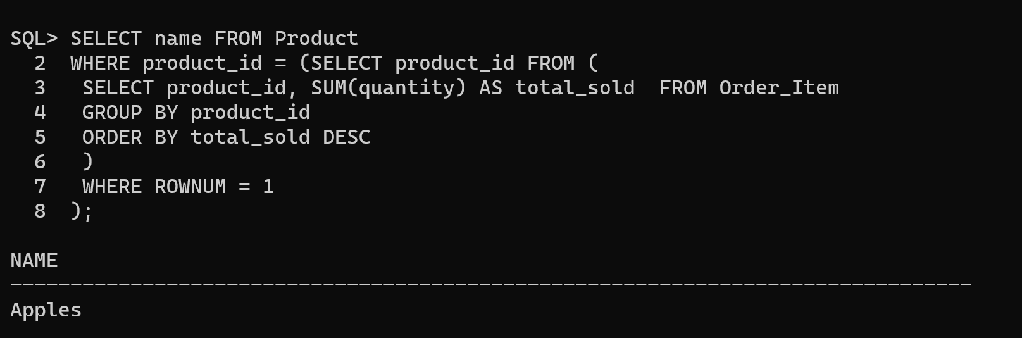

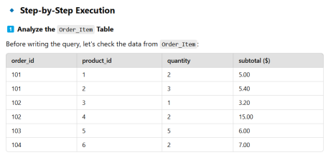

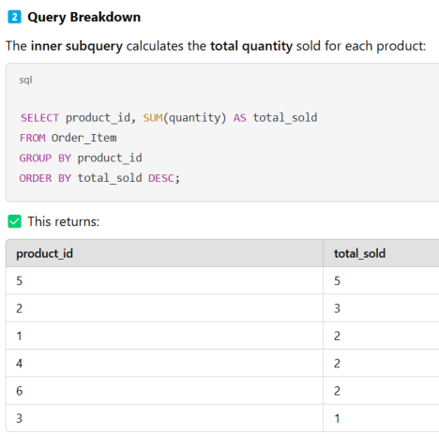

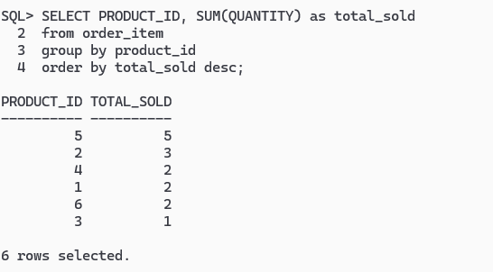

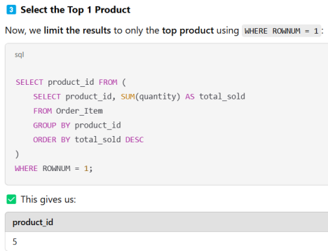

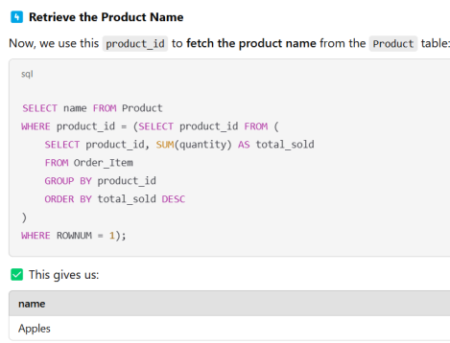

**Retrieve employees who earn above the average salary of all employees** SELECT * FROM Employeee

WHERE salary > (SELECT AVG(salary) FROM Employeee);

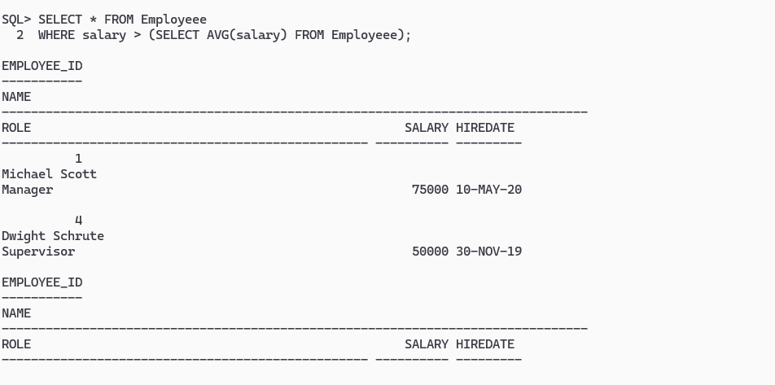

**Find customers who placed orders only in 2023 but not in 2024**

SELECT * FROM Customer

WHERE customer_id IN (

SELECT customer_id FROM Order_Details

WHERE order_date BETWEEN TO_DATE('2023-01-01', 'YYYY-MM-DD') AND TO_DATE('2023-12-31', 'YYYY-MM-DD') )

AND customer_id NOT IN (

SELECT customer_id FROM Order_Details

WHERE order_date BETWEEN TO_DATE('2024-01-01', 'YYYY-MM-DD') AND TO_DATE('2024-12-31', 'YYYY-MM-DD') ); 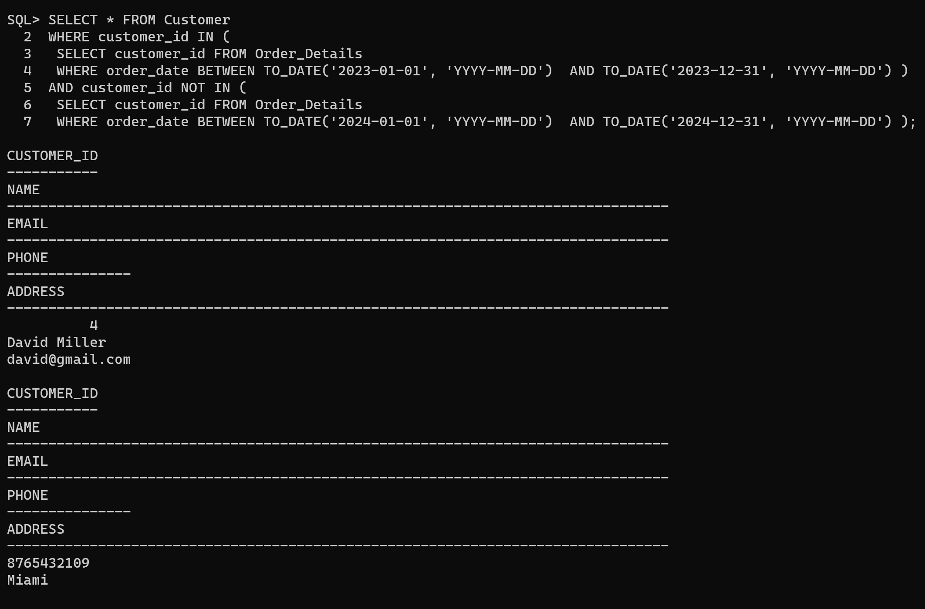

**Subquery Tasks**

1. Find customers who placed orders over **$50**.

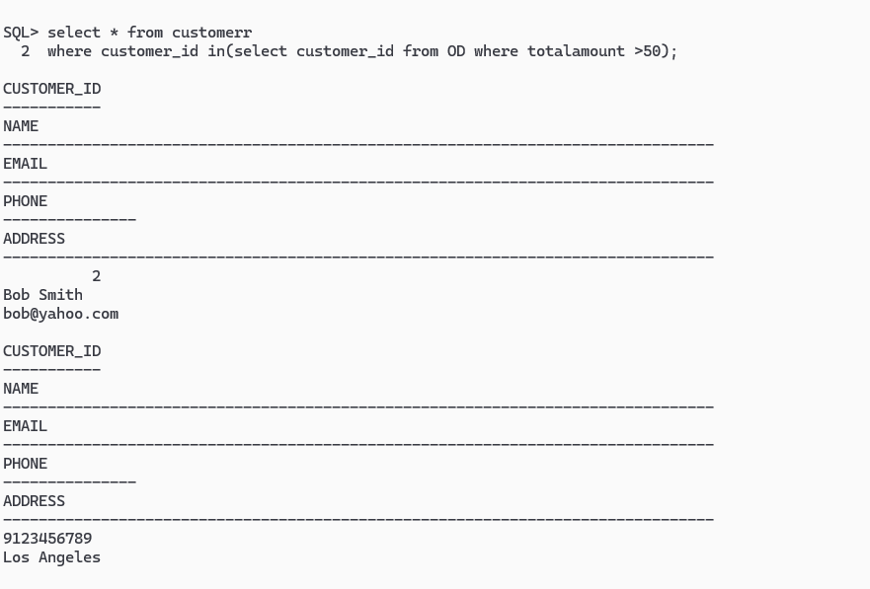

2. Retrieve products that cost more than the **average product price**.



3. Find employees hired after the **most recent hire date of a cashier**. 4. List customers who **haven’t placed any orders**.



5. Retrieve employees who earn **above the average salary**.

